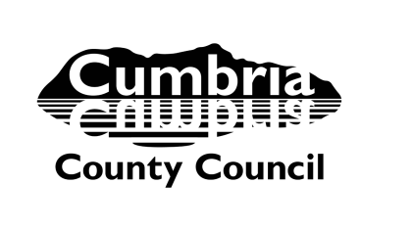

Learning Improvement Service – Early Years

Early Years Adviser/Area SENCO report – initial visit report (individual child)

Completed by |  | Date

Child’s details
Name
DOB |  | Age (months) |  | Home language
Setting/School
SENCO |  | NC Year group |  | Child looked after (CLA)

SOGS (delete if appropriate)
Schedule of Growing Skills II (SOGS) – GL Assessment*
Completed by (Examiner)
Date carried out |  |  | Chronological age (months)

Skills area | Age in months | Skills area | Age in months
Locomotor |  | Speech and language
Manipulative |  | Interactive social
Visual |  | Self-care social
Hearing and language |  | Cognitive
Comments
* The GL Assessment Schedule of Growing Skills II is designed to identify children with delayed development by assessing a child’s performance in each of a range of developmental areas. The developmental age levels serve as a guide to the child’s skill development

Advice Given
Suggested key strategies

Agreed actions for setting/school

Copies to
Setting/School SENCO
Parents/Carers – setting/school to share/provide a copy
Early Years and Childcare Team Manager
Confidential file – Learning Improvement Service

Further information and guidance can be found through the:

For professionals only: Early Years Area SENCO advice line every Wednesday 3.00 – 6.00pm call 0300 303 3897

And/or the Cumbria Local Offer at localoffer.cumbria.gov.uk.

