

Emotionally Based School Avoidance Support Plan
fid.cumberland.gov.uk

Contents
Introduction 3
Assess, Plan, Do Review 3
Access to Education Support Plan 4
Action Plan 7
Programme Review 2023 9
Ways of Offering Support. 10
Things to Consider. 11
Appendix 1: Strategies for Gaining Pupil Voice 12
Timetable review 12
Anxiety thermometer or scale 12
Card Sort: Function of School Avoidance 12
Ideal Classroom/School 12
General Wellbeing Measures 13
Life Graph 13
5 point scale 13
Externalisation 13
Sensory Aspects of School 14
Appendix 2: Gaining Parental Views 15

This plan was developed by the Cumbria County Psychological Service, with input from the Cumbria Multiagency Emotionally Based School Avoidance Steering Group. In producing the plan, we have drawn on previous work by West Sussex Educational Psychology Service, Sheffield Educational Psychology Service and Lancashire Educational Psychology Service. We are grateful to all these colleagues for their insights.

Introduction
‘Emotionally Based School Avoidance (EBSA) is a broad umbrella term used to describe a group of children and young people who have severe difficulty in attending school due to emotional factors, often resulting in prolonged absences from school’.
(West Sussex County Council, 2022)

At times EBSA is also referred to as Emotionally Based School Non-Attendance (EBSnA).

The attached support plan can be used by schools, with or without input from other agencies, to provide a framework for planning and implementing interventions for students who show Emotionally Based School Avoidance.

Assess, Plan, Do Review
Assess: Several tools are suggested for gathering information from students, families and staff. There is no expectation that all of these are used. Choose the ones that seem most appropriate to the situation and consider any other information already available. Your school Educational Psychologist may be able to help with other assessment tools if needed.

Plan: Planning begins with formulation about the possible functions of the school avoidance behaviour.
Key functions identified in research include:

- To avoid uncomfortable feeling brought on by attending school.
- To avoid stressful situations
- To reduce separation anxiety
- To pursue reinforcers outside school

Plans should be co-produced with input from schools, families, young people, and other agencies if they are involved.

Do: The plan provides space to record the next steps that have been agreed, any interventions that might be needed, and more general strategies to support the student’s attendance. These supports are agreed by all parties at a planning meeting. Flexibility of response based on individual circumstances and functions is key.

Review: The plan should be reviewed and adjusted frequently. Initially this may need to be at least every 2-4 weeks. If needed, other agencies can be involved in supporting development of the plan for example, Educational Psychologists, Specialist Teachers, Access and Inclusion Officers, Mental Health Professionals, other Health Professionals, Alternative Provisions, or agencies working with families at home.

If you require support with using the plan, please contact your school Educational Psychologist.

Access to Education Support Plan
Name |  | D.O.B
School
Background: for example, health, learning or social needs
Other agencies involved
Pupil Voice: list the tools used to gather the pupil’s views: see appendix 1.
Family Voice: who met with the family to gather their views and when? See appendix 2
Views of Key Staff: which staff in school have been consulted? See appendix 3.

Description of behaviour in school: including when it first occurred, what is the current rate of attendance? Are there any patterns? What does the behaviour look like?
Outside School: Does the pupil attend any extracurricular activities? Do they go out with their family - if so, where and with whom? What does the behaviour look like at home?
What Strengths and Protective Factors have been identified?
For example, aspirations or ambitions, positive relationships at home and school, positive experiences at school, what worked/was helpful in the past? Are there times when things are better – and why?

What is the function of the behaviour? (There may be more than one function)
To avoid something or situations that elicit negative feelings or high levels of stress (e.g. fear of the toilets, playground noise, busy corridors, tests/exams).

To escape difficult social situations (e.g. feeling left out at playtime, reading out loud in class, public
speaking, working as a group).

To get attention from or spend more time with significant others (e.g. change in family dynamic,
concerned about the well-being of a parent).

To spend more time out of school as it is more fun or stimulating (e.g. shopping, playing computer games, spending time with friends).

What ideas are there about why this behaviour is happening? List them here.

Action Plan
Name |  | N.C.Y
Key adult |  | Safe place
Date of Plan |  | Review Date
Regular communication between home and school will take place: When? Who? How?
List key areas to work on identified by assessments
For example, peer/adult relationships, anxiety, attachment issues, learning difficulties, access strategies, sensory issues, transitions, morning routines, sleep, out of school activities. There may be others….
What next steps have we agreed with the child?
What is a realistic expectation given the starting point? Be careful…’targets’ could create pressure and if not achieved could lead to increased anxiety. Consider using the ladder template – appendix 4.
What actions will we take to achieve this and what strategies will we use?
Include actions for school and home

What general strategies can we use?
Things that staff and other students can do/not do to help the pupil feel better in school. Things the pupil can do to help themselves feel better. What to do if the pupil appears anxious or if staff notice difficulties.
Do we need to involve any other people to help us and if so, what support do we want from them?
Review of Progress
People involved in writing this plan
If needed, guidance on the use of part time timetables can be on the Family Information Directory Professionals Hub

Programme Review 2023
The EBSA initiative was reviewed with reference to ‘Working Together to Improve Attendance’ (Department for Education). After consultation with schools and settings, the following guidance gives further insight into how children and young people with EBSA can be supported.

Regardless of who is supporting the young person/ family the process of recovery involves establishing a pathway back to learning and potentially back into school or college, with the following possible stages:

- Rebuilding relationships with key, consistent people in the young person’s life.
- Reconnecting and gaining confidence of family and young person.
- Re-engaging in learning.
- Returning to a learning environment.

Each step can be slow and must go at the pace of the young person. There may be gains but small upsets may result in a return to a previous step. Expect that there will be steps forward and back.

Maslow’s Hierarchy of Needs is a useful model to keep in mind. If the young person is highly anxious or feels threatened, then they will not engage successfully.

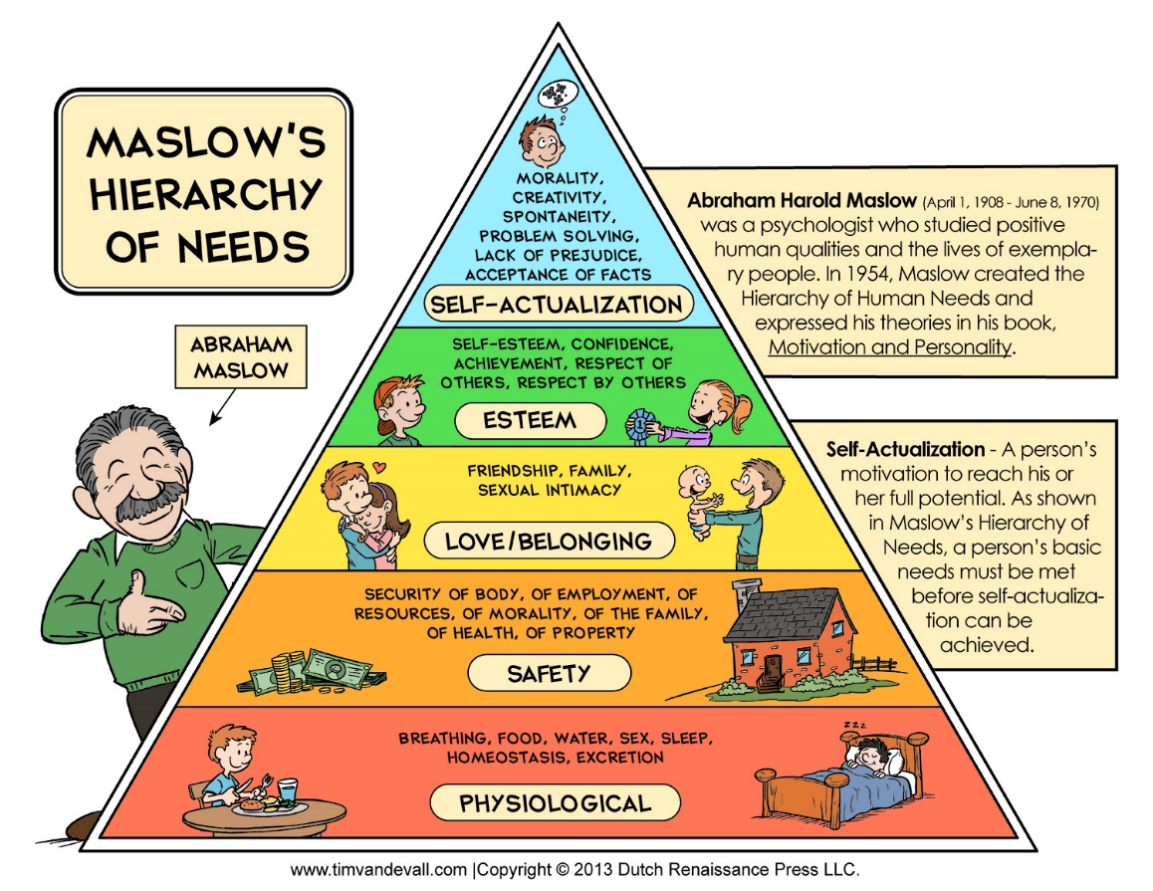

Ways of Offering Support.

A key adult who is given the time to reengage with the young person in their own environment, build up a relationship, confidence and a ‘can-do’ approach. In some cases, this may be about engaging in activities in the home or garden prior to return to school.

Getting to know what skills the young person needs to develop, what are their anxieties, what are the causes of these anxieties, what feelings and emotions are at play.

Encourage other activities which are increasing self-worth and confidence such as social contact with peers, out of school clubs/activities and moderated online contacts.

Support the continuation of friendships with peers and relationships with key staff.

Consider possible options such as:

- A flexible programme of learning which involves use of a laptop/ AV1 robot/ on-line programme which maps onto what is being delivered in school, supported by the mentor using subjects which the young person is going to succeed at. This means the young person keeps up with the curriculum at home, and also has some contact with teachers and pupils.

- Re-engaging in learning off the school site (if the school environment is a barrier to learning) to move the learning out of the home and de-sensitise the young person to another environment where they can feel safe and not under pressure or threat. Consider learning in settings such as a library or other community venue. For those in Y10/11 this may include a work experience.

- Getting back to learning in a space on the school site where variables are controlled (e.g., in student support). This may still involve using the laptop/ AV1 until such a time learning can be in class. Working towards a balanced timetable of activity considering the young person’s needs and gradually returning them to the curriculum with mentoring in the week to support.

- Joining initially for motivating activities such as breaks, a lunchtime club, or a themed day.

Things to Consider.

Take things one step at a time. Small increments of change are more likely to be sustained. Don’t rush things or create too much demand. Focus on what has been achieved rather than what has not been achieved.

Make sure there is a routine at home which is manageable. Do not introduce demands which will turn this routine upside down. (Young people may stay in bed all day to avoid going to school – if necessary, split ‘school’ from learning and encourage learning at a different time).

Avoid going overboard with praise and encouragement – this can make the young person feel self-conscious/ increase the stress to do it again.

Join the young person on their journey rather than taking them on yours. Create a plan involving the young person and parents. Use the ideas of the family/ young person to develop agreed outcomes.

Plan for reasonable adjustments to the environment and demands. Consider what is important and what is not important (e.g., how important is it they wear the school uniform if this is a barrier to getting them to school?)

Consider scripts – for the young person, and staff to explain to other young people and parents what is happening.

Keep a positive view of families and carers and work with them to plan and resolve difficulties. Maintain good and regular communication with the young person and their family – face to face contacts may be more effective in some circumstances.

Consider online resources such as ‘Kooth’ for mental health supports.

Provide training on EBSA and the young person’s needs, so staff understand what is happening and why.

Use expertise within setting such as Emotional Literacy Support Assistants, pastoral/family workers and school counsellors.

Develop a Team Around the Child/Family. Work with other agencies who are involved such as Family Action, Educational Psychologist, Behaviour and Emotional Wellbeing Officer, Specialist Advisory Teacher, CAMHS, social workers, and health professionals.

Appendix 1: Strategies for Gaining Pupil Voice

Timetable review
A tool often used by adults working with students showing school anxiety is to offer CYP the opportunity to review their timetable and places around school, identifying which lessons and areas are associated with a lot, some, or no anxiety. Using a red, amber and green anxiety code may help. Bear in mind that some CYP may experience anxiety just by thinking about some lessons / lunchtimes / break times / transition to or from school and may need the support of an empathetic adult during this activity Exploration of the issues arising from this can provide useful information.

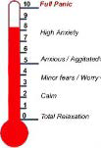
Anxiety thermometer or scale
Using an anxiety thermometer or scale can help the young person to start to make links between their emotions and environmental/contextual triggers. Consider the physical environment (toilets, hall, corridors, changing rooms, outside), times of day (arrival, home time, break and dinner times) and specific lessons and activities (reading aloud, group work, writing, tests). Using a map of the school building can be helpful when exploring the impact of the physical environment on their anxiety.

Card Sort: Function of School Avoidance
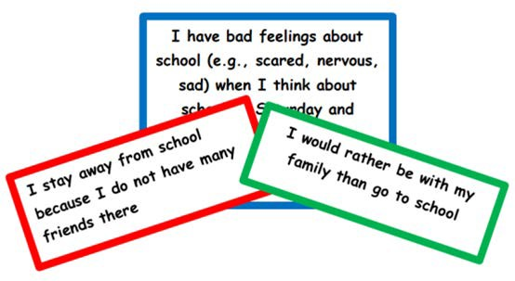
This card sort activity, based on a School Refusal Assessment Scale developed by Kearney (2002), has been devised by Sheffield EPS as a tool for staff to use to develop a greater understanding of a young person’s school avoidance. The 24 statements are colour-coded by the function of behaviour identified by Kearney and Silverman (1990). The cards and guidance on how to use are available from the EP Service.

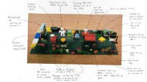
Ideal Classroom/School
This tool developed by Williams and Hanke (2007) can be used to gain an insight into which features of the school (people, environment, lessons etc.) young people would like to change and why. This activity can be undertaken using Lego, play equipment and/or drawing. There is a presentation on drawing the ideal school here with further information about Personal Construct Psychology:

Drawing the Ideal School

General Wellbeing Measures
A variety of evidence-based resources for measuring student wellbeing across the age range can be found here:
Wellbeing measurement framework for schools | Anna Freud
These can help to identify factors impacting on student wellbeing both within school and at home.

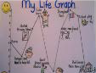
Life Graph
Collaboratively developing a life graph or path with the young person may help them to consider when their EBSA started, what else was happening in their lives at this time, what events and experiences led up to this point and how they interpreted these, as well as looking at what they would want in the future.

5 point scale
5
4
3
2
1
The 5 point scale already used in many schools can be used as a way of supporting CYP to understand and manage overwhelming feelings. It can be used with CYPof all ages and begins with an exploration of emotions. CYP can then use the scale to describe how they are feeling, and what these feelings may look or sound like; they can explore situations that may make them feel a certain way and move to describing how to reduce overwhelming or difficult emotions. The scales that the CYP makes can be used as a communication tool for example, making into a keyring or using different coloured cards or bracelets to let adults know that they feel a certain way.
There are free downloadable resources available at 5 point Scale

Externalisation
It can sometimes be helpful to support the CYP to externalise the anxiety, so that the CYP can start to view their anxiety as separate from their essential self. This is a great opportunity to get creative and have fun using paints, playdough, clay and collage materials as you explore the anxiety with the CYP. You could try asking:
- What would you call the feeling you have when you think about going to school?
- If your anxiety was a ‘thing’, what would it look like?
- Can you draw/paint/make it? What would it say?
- How does … get in the way of you coming to school?
- When is … in charge and when are you in charge?

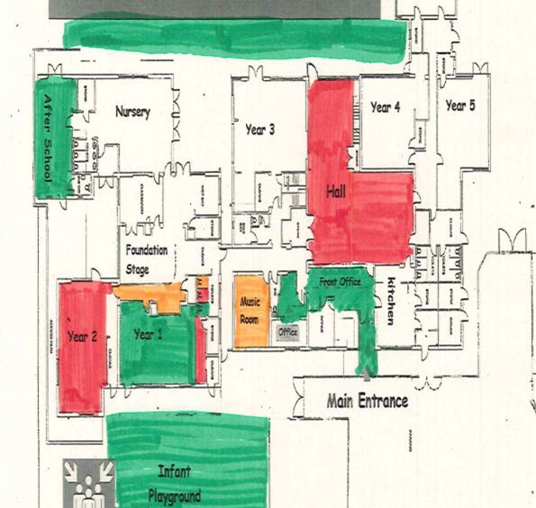
Sensory Aspects of School
Some children find that noises, busy environments, visual experiences, smells or tactile sensations can lead to anxiety and sensory overload. After talking about their senses (using age-appropriate resources) try RAG rating different areas/rooms/lessons in school from a sensory perspective. Note any likes and any experiences or areas that they find hard.
There is a general sensory checklist here with ideas for strategies.

Appendix 2: Gaining Parental Views
Theme | Possible questions
Family dynamics  It can be helpful to gain an understanding the young person’s life journey and significant events which may have impacted upon their lived experiences. | - Could you describe your family? Or draw your family tree?  - Who is X closest to in the family? Has this always been the case?  - Have there been any changes within the family recently? Or are there  any upcoming changes in the near future?  - Was anything different in your family at the time that you noticed X’s difficulties increasing?  - Have there been any significant life events that X has experienced? Or  any import1ant losses/bereavements/long-term illness?
Strengths, interests and aspirations | - What is X good at? What do they like doing?  - Do they have any hopes for the future? Do they know what they want their life to be like when they are an adult?
Developmental and educational history | - What was X like as a young child?  - Can you tell me about their early experiences at school? The primary school, at the start of secondary school?
Relationships | - Does X talk about any other children? What does s/he say?  - Does X talk about any adults within school? What does s/he say?  - Who does X get on with…who doesn’t X get on with?  - Does X interact with other students out of school?  - Which friendship groups are significant?
Academic progress | - School should be aware if the young person has identified SEN needs  and should ask about these needs and the support in place.  - If there is no identified SEN school should ask if they have any concerns, or if the child has spoken about difficulties.
Behaviour and symptoms of anxiety | - When X is worried what does it look like?  - What do they say they are feeling?  - Is X’s sleeping and eating affected?
The child’s view – fears and worries | - Has X spoken to you about what X finds difficult about school? What do  they say?
The child’s view – going well in school | - Has X mentioned anything that is going well in school? (e.g. teachers,  lessons, friends)
Typical day | - What does a typical day look like for X / yourself when they do/do not attend school?  - Take me through it, what happens from the moment they wake, to the moment they sleep…

Theme | Possible questions
Parental views on the reasons for EBSA | - Why do you think X has difficulty attending school? (ask each parent  separately)  - If (other parent/ sibling/Grandparent) were here what would they say?  - Are there any differences of views about the reasons and what should  be done within the family?
Exceptions  These questions can help shift the focus away from the  presenting problem, to consider aspects within a situation which are working well or supporting the young person not to get worse. | - Tell me about the times when X is not feeling X  - Tell me about the times when X is feeling less X  - Tell me about the times when X has coped well  - Tell me about the days/times of day when you think something has gone  well for X. What is different during these times?  - Tell me about the times when X has managed to go to school. What  was different about these times?  - Tell me what other people have done that has been useful/helpful for X.

